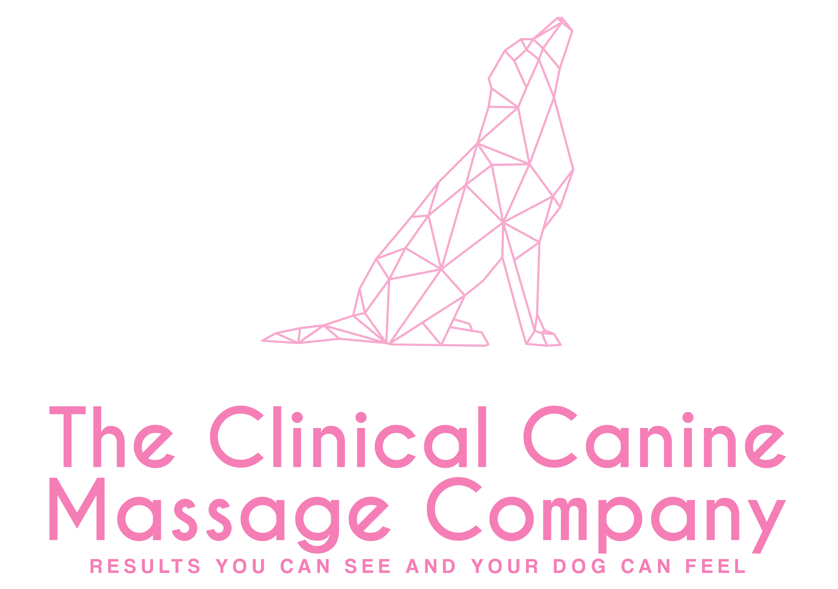

Owners Name
Address
Telephone & Email

Dog’s Details

Name |  | Breed |  | Sex
D.O.B |  | Colour |  | Neutered?

I declare that I am the legal owner of the above-named dog and that all information presented is correct to the best of my knowledge. I give consent for my dog to have massage therapy by Tracey McElroy-Baker.

Owner Signature: ………………………………. Print Name: ……………………………. Date: ………………………

Veterinary Surgeon
Practice Address & Tel. No & Practice Stamp

YOUR VET MUST COMPLETE THIS AREA BELOW ALONG WITH A SIGNATURE
Reason for approach, treatment, areas of concern
Is the dog on medication? If yes, what:

In your opinion is the dog named above in a suitable state of health to undergo massage therapy. Yes/No*
*Delete as applicable Signature of Veterinarian……………………… Date……………………

I Tracey McElroy-Baker respect the Veterinary Surgeons Act 1966 and Exemption Order 2015 by never working upon an animal without gaining prior veterinary approval

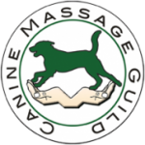

Canine Massage Guild - Clinical Canine Massage Therapy

- I Tracey McElroy-Baker, am a member of the Canine Massage Guild and I have trained for 2 Years on the Clinical Canine Massage Practitioner Programme externally accredited by LANTRA* via the Canine Massage Therapy Centre.

- My professional membership, training and credentials may be checked by visiting the online professional therapist register www.k9-massageguild.co.uk/therapistregister

- More information about me can be found on my own website www.clinicalcaninemassageco.co.uk or I welcome your phone call on 07507 704228

- The Canine Massage Guild participated in the world’s first clinical trials with Winchester University and Sparsholt University Centre in 2018
https://bvajournals.onlinelibrary.wiley.com/doi/10.1002/vetr.586

- Each year I commit to a minimum of 25 hours CPD as part of the Canine Massage Guild’s strong code of ethics and conduct.

- I hold my own professional indemnity and public liability insurance which is audited annually by the Canine Massage Guild.

- I always abide by the Veterinary Surgeons Act 1966 and Exemptions Order 2015, by never working on an animal without veterinary consent. As stated by the RCVS, “Physiotherapy' is interpreted as including all kinds of manipulative therapy” (Section 19.21), thus including massage therapy. Manipulation under massage therapy is limited to soft tissue and testing a joint’s range of motion. I do not manipulate joints like a chiropractor.

- I specialise in the use of Myofascial Release, Remedial Sports Massage, Deep Tissue Massage and Swedish Massage as well as the Lenton Method™ of Myofascial Release. More details may be found on the Canine Massage Guild website.

- I ensure continuity of client care by providing a written report back to the surgery upon completion of a client’s initial sessions.

- I comply with GDPR Compliance 2018 and the Data Protection Act 1998.

- Clinical Canine Massage Therapy is suitable for soft tissue injury rehabilitation and for the chronic pain management of orthopaedic conditions as well as pre and post-operative care. It is commonly used amongst sporting, performance, and agility competitors too. If you would like an Integrated Veterinary Care Initiative educational pack on Clinical Canine Massage for your surgery, please contact me and I will be more than happy to send one for your perusal.

- I am also available for Lunch ‘n’ Learns or client presentation evenings to speak on Clinical Canine Massage Therapy.

*formerly Therapeutic Canine Massage Diploma accredited by Ascentis

I Tracey McElroy-Baker acknowledge and respect the Veterinary Surgeons Act 1966 and Exemption Order 2015 by never working upon an animal without gaining prior veterinary consent. As stated by the RCVS, “physiotherapy” is interpreted as including all kinds of manipulative therapy (Section 19.21)

